Datasets link
e.g. search “fish”
1.
https://data.world/datasets/
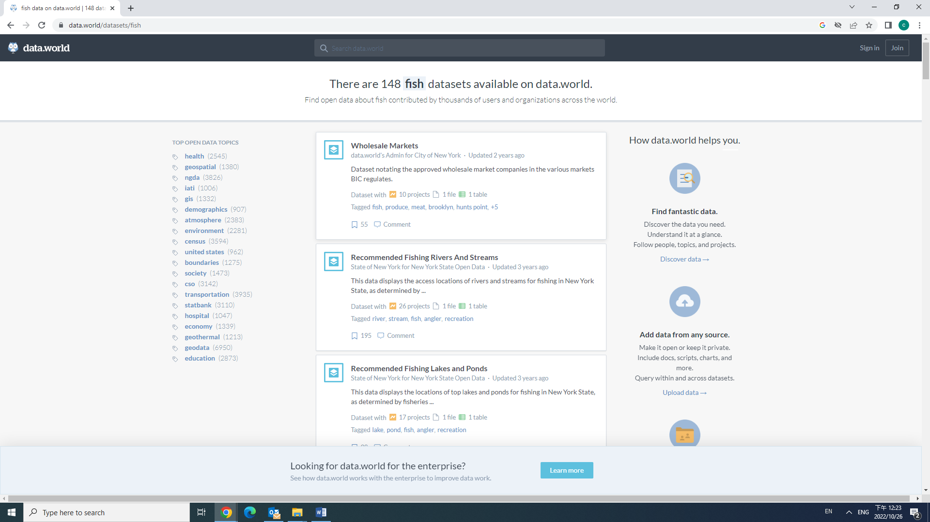

2.
https://www.kaggle.com/datasets/
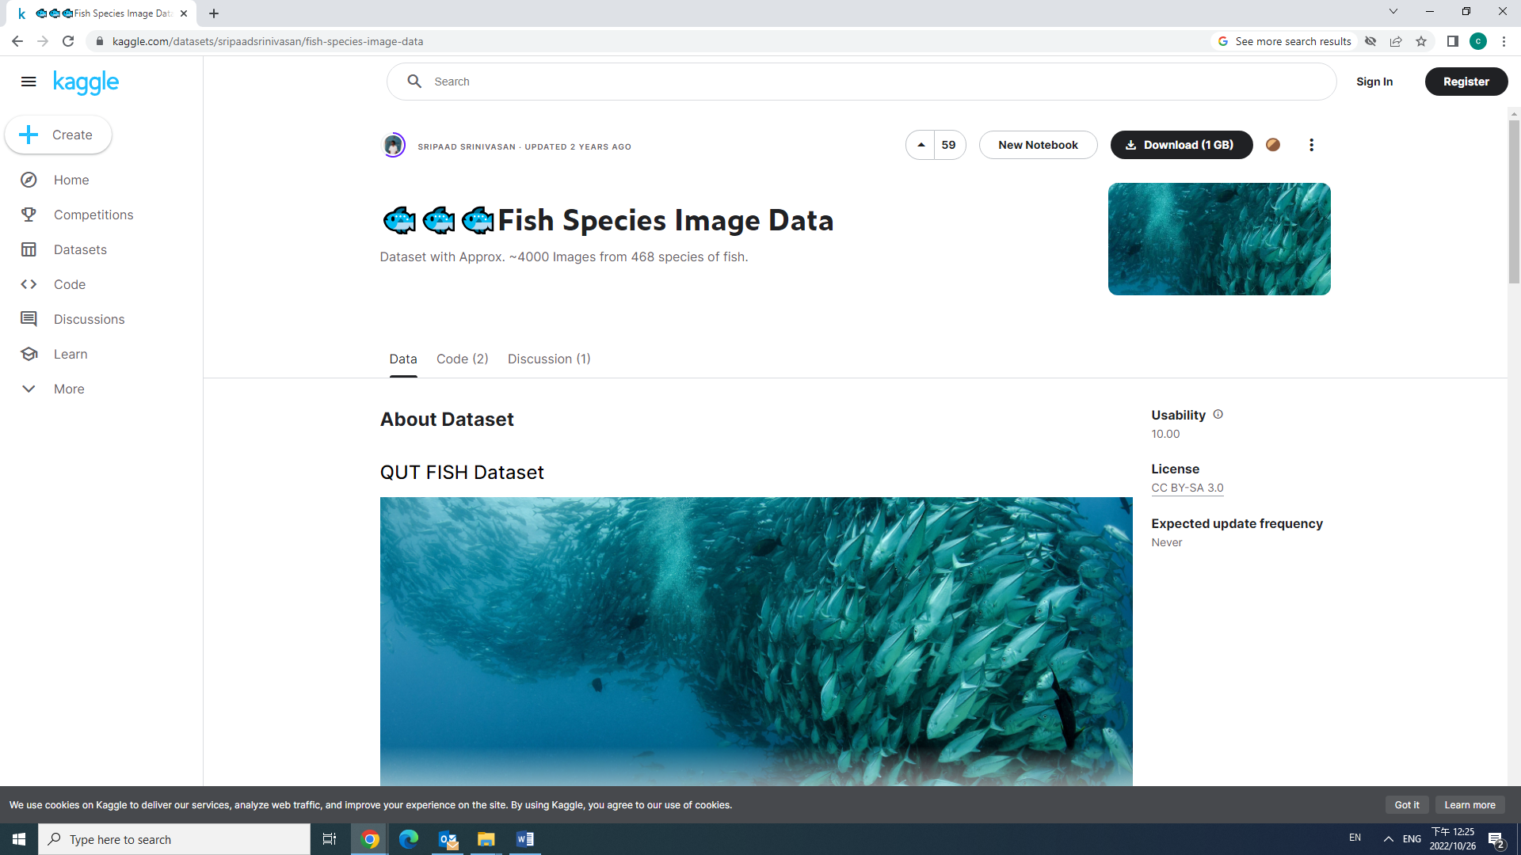
3.
https://globalwetlandsproject.org/computer-vision-resources-fish-classification-datasets/
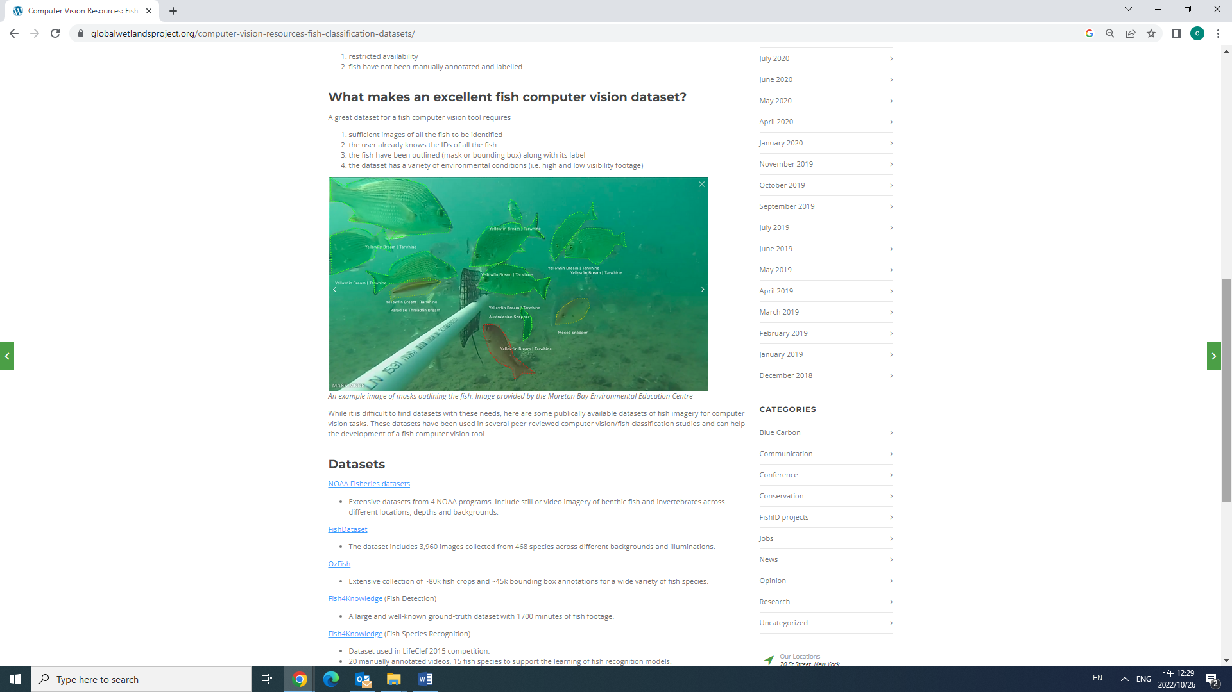

4.
https://github.com/alzayats/fish-datasets
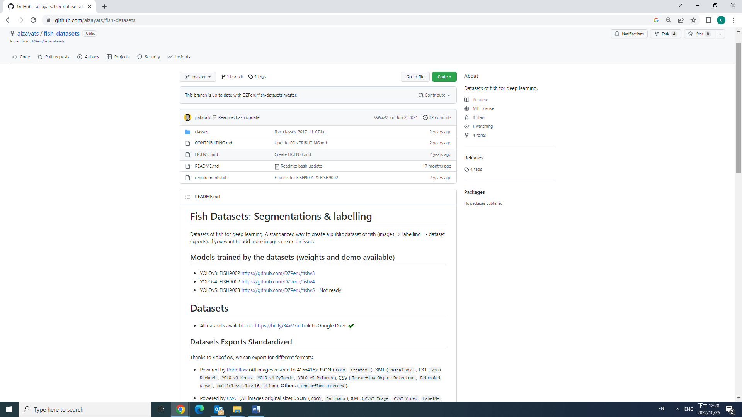
5.
https://www.worldfishcenter.org/knowledge/data-and-tools
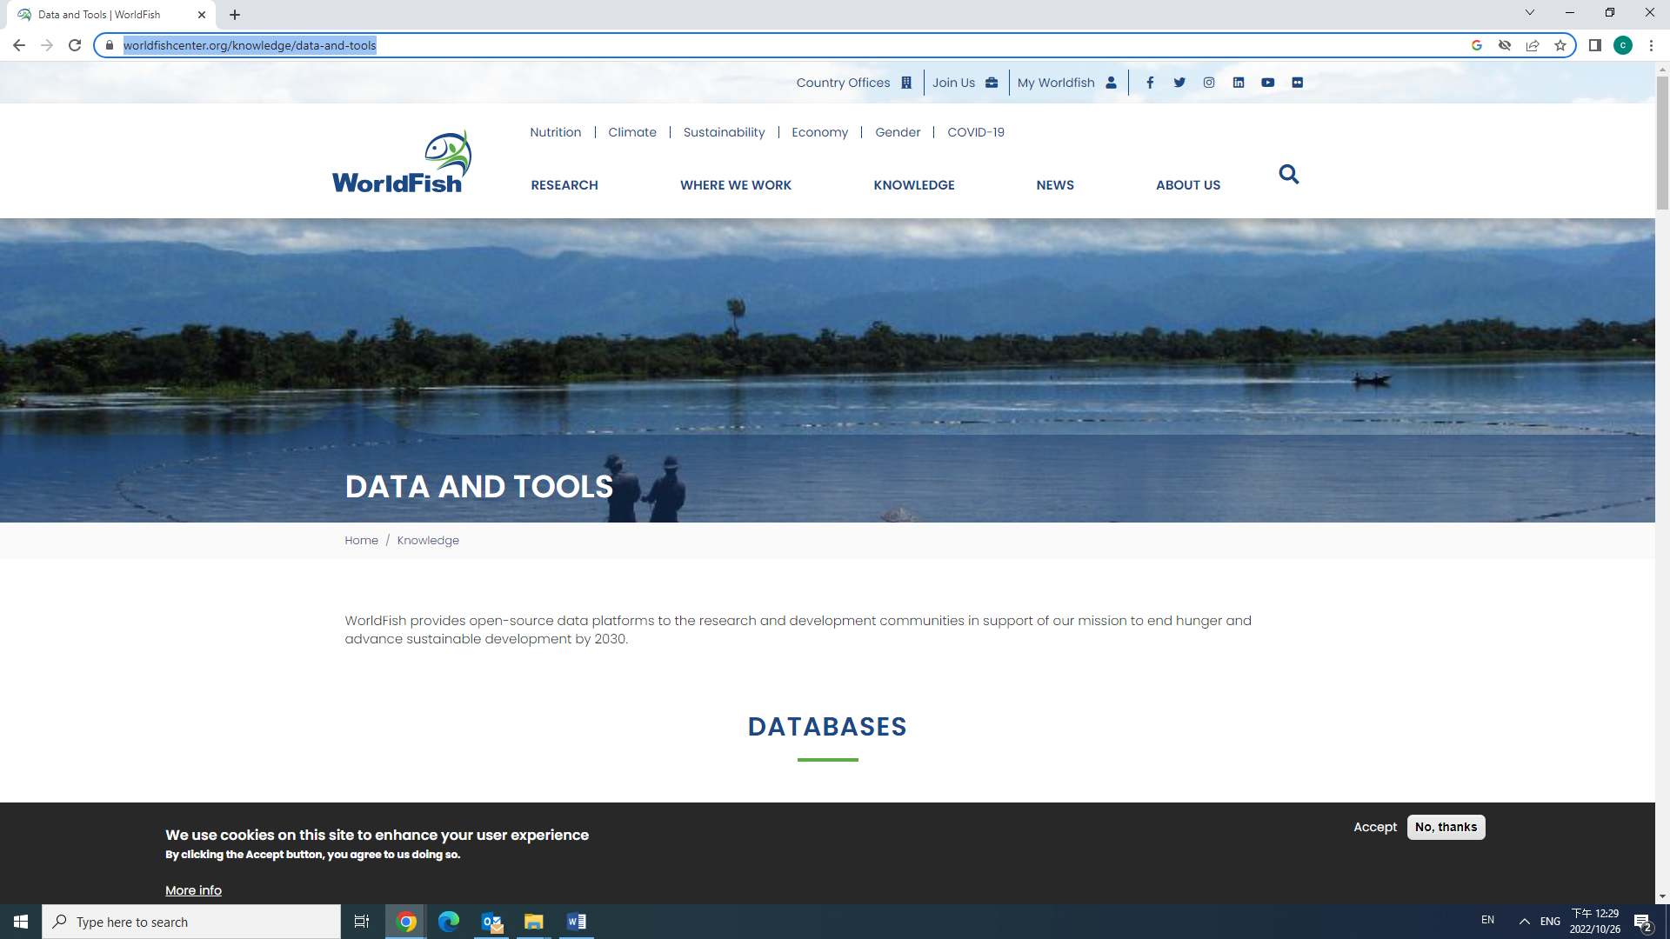
https://www.gbif.org/dataset/84b9a51f-ec2e-41dc-9d7a-1e3aa411b939
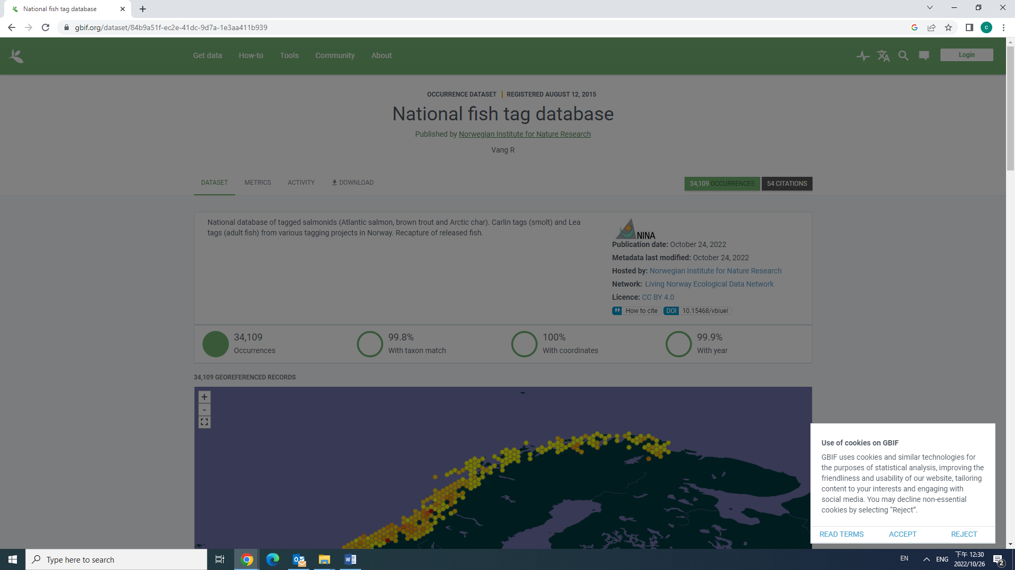

6.
https://arxiv.org/abs/2106.09178
for fish detection and fine grained categorization
